Bachelor/Diploma thesis Name Surname 20XX

Bakalářská/Diplomová práce jméno příjmení 20XX

Czech Technical
University
IN Prague

Faculty
OF ELECTRICAL
ENGINEERING

BACHELOR/diplomA THESIS

20XX

NAME
SURNAME

Pozn.: První strana reprezentuje předepsaný formát desek vazby.

Zde vložte originální zadání

Czech Technical University in Prague
Faculty of Electrical Engineering
Department of the thesis assignment (not supervisor‘s)
Bachelor/Diploma thesis (select one, similarly for book cover)

Thesis title

Author:
Supervisor:
Supervisor – specialist (if exists):
Study program:
Prague 20XX

Official assignment
- Printed from KOS
- For digital version, insert without signatures
- For print, signed version obtained from the department secretary
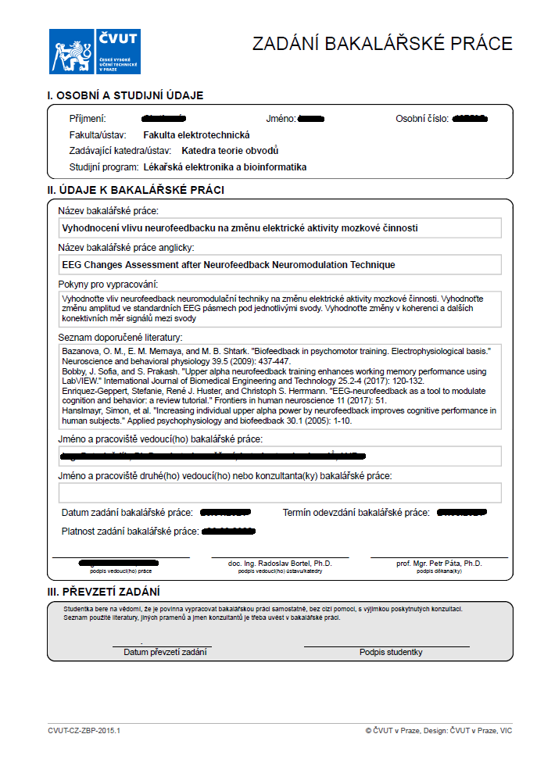
Warning: Insert all pages of multi-page assignment

Declaration
I declare that the presented work was developed independently and that I have listed all sources of information used within it in accordance with the methodical instructions for observing the ethical principles in the preparation of university theses.
Prague, date ....................... ..............................
Author’s signature
(without in digital version)

Acknowledgement
Thank here those who have helped and supported you during the research and writing process, e.g., supervisors, and family. Do not forget to thank the staff and institutions who participated in data collection or provided technical background, etc. There is a place for dedication. Exclude thesis opponent.

Abstract
Short annotation of the work about half a page long. It should give a much shortened version of your work, making clear what you did and why and what results you achieved. The abstract can be structured to four paragraphs: introduction, methods, results, and conclusion. We recommend to write it last, after the rest of the text.

Keywords: 3-5 words describing the key concepts, to assist with future search

List of abbreviations (example)

iEEG intracranial electroencephalography
PET positron emission tomography
DNA deoxyribonucleic acid

List of figures (optional)
Figure 1: Mendeley Web importer. 12
Figure 2: Mendeley Reference Manager. 12
Figure 3: Mendeley MS Office plug-in. 12
Figure 4: Logo of CTU in Prague. 14

List of tables (optional)
Table 1: List of probands 14

Contents
1. General instruction 9
1.1. Frequent mistakes 9
1.2. Citation 10
1.2.1. Mendeley – an example of reference management software 11
1.3. Equations 13
1.4. Figures 13
1.5. Tables 14
2. Headings (level 1) (20 pt) 15
2.1. Subsection (level 2) (16 pt) 15
2.1.1. Sub-subsection (level 3) (14 pt) 15
References 16
Supplementary 17

- General instruction
Bachelor/diploma thesis requirements define by Dean’s directive for diploma thesis and the comprehensive final examination in Bachelor’s and Master’s programs at the FEE at CTU (SD_2015_02) (https://fel.cvut.cz/en/education/rules/SD_2015_02.pdf). Study them and follow the instructions.
Two hard copies of the thesis deliver to the assignment department before deadline announced in Academic Calendar (https://fel.cvut.cz/en/education/calendar.html). Upload also the digital version to KOS.
A thesis is usually in the range of 20 to 50 pages for a bachelor’s thesis, or 40 to 80 for diploma thesis in A4 format (without attachments) printed on both sides, usually in font 11 and bound into one part in a soft board with cardboard board (not spiral).
Recommended page margins are 25 mm, 35 mm at the spine. Use line spacing 1.5, font size 10-12 pt, 20, 16, 14 pt in the headings according to its level.
We recommend writing in TeX or LaTeX. You can use predefined templates:
- http://petr.olsak.net/ctustyle-e.html
- https://github.com/tohecz/ctuthesis
- https://www.overleaf.com/latex/templates/sablona-pro-psani-disertacni-prace-na-cvut-fel/ptpvbxhsjdmg
Using TeX/LaTeX helps you with graphical and style formatting.
If you prefer Microsoft Word (MS Office), use this manual as template.

  - Frequent mistakes
Avoid common mistakes with the following recommendations:
- Use short sentences, ideally with a main clause and one subordinate clause.
- Pay attention to clearly expressed subjects and objects in meanings.
- The text must be comprehensible also without figures and tables. Everything important you describe in the text. Details can be referred to in the figures. Legend of the figure repeats the main meanings from the text and extends them through the details. The figure with legend must be comprehensible separately. The figures can be taken from another publication, but must respect copyright and cited with statement: “taken from [1]”
- Write only about things directly related to the issue of your thesis. A smaller nuber of pages of facts will be evaluated better than the amount of insignificant ballast. The focus of the work should be on what you did yourself. Remember that the reader (opponent) must read the work carefully, so do not overwhelm him with unnecessary information and do not distract him.
- The thesis must be meaningfully divided into sections and subsections. Style depends on the type and differs between methodological and experimental work. Consult it with your supervisor and design the appropriate structure.
- Try to make the sections follow each other. Tell a story. E.g., experimental work is divided into five blocks: introduction with theory (historical background, state of the art), methodology (ideas, search procedure, hypothesis), results (found clues and evidence) and discussion (the killer is the gardener: how we found him and what we were wrong about), conclusion (lessons learned).
- Write single digits in words, instead of results values, e.g., two subjects, but 1°C; five apples, but 5 mm.
- One-letter prepositions or articles should not be at the end of a line. Use the coupled space: in LaTeX symbol „~“, for MS Word „ctrl + shift + space bar“.
- Hyphens are used to link elements in compound words. The en-dash is approximately the length of the letter n, and the em-dash the length of the letter m. The shorter en dash (–) is used to mark ranges and with the meaning “to” in phrases like “Dover–Calais crossing.” The longer em dash (—) is used to separate extra information or mark a break in a sentence.
- In MS Word, use “page break” for new page (ctrl+enter).

  - Citation
Respect international standard ISO690 which specifies a linked reference form and type (article, book, software, webpage, etc.). Technical text usually uses numeric referencing of individual facts within a sentence before the dot: “Body temperature is 36-37°C [1].” Numbering reflects the order of occurrence in the text.
Using paraphrased text or referencing the whole paragraph is permissible and uses numeric reference inserted to the end of the text after the dot: “Body temperature is 36-37°C, but higher during inflammatory. [1]” However, prefer factual referencing instead.

Use reference management software that helps you to collect, sort, search, citation inserting, and their formatting. LaTeX uses BibTeX, BibLaTeX. Universal managers usually contain BibTeX exporter or MS Office extensions, e.g., free Mendeley, Zotero, or paid EndNote. Warning: not all software supports all platforms, e.g., macOS, Google Docs.

    - Mendeley – an example of reference management software
Mendeley allows to you import references directly from web-browser search (Chrome) into a personal database (cloud, manager for desktop). Collected items can be exported in BibTeX format or inserted directly into MS Word using a plug-in.
Registry your account using your private e-mail (no faculty) on www.mendeley.com. Here you find download links for desktop manager (Reference Manager), Chrome web-browser extension (Web Importer), and MS Office plug-in (Citation Plug-in).
Find your sources (articles, books) by the CTU Central Library http://knihovna.cvut.cz/en/, or Google scholar https://scholar.google.com/. Import the reference from the web page using Chrome Web Importer, which automatically generates the fields for the database. An example of an article Chang et al. (2018) [2] shows in Figure 1. Select the found reference in the window and save it into your library.
Sync the database in the desktop app (cloud and offline) and check/edit all reference fields: type of publication, authors, title, publisher, volume, issue, year, page, digital identifier DOI; see Figure 2.
Referenced items can be exported as BibTeX file (*.bib). MS Office plug-in allows to insert references directly to text, see Figure 3. Citing style is not preferred, but has to be uniform in the whole thesis and fulfills ISO690. Numeric references are in order of occurrence in the text, in square brackets, typically for IEEE style. A reference list will be generated like the last regular section (before supplementary). Multiple references are noted in form: [1, 3]; [1, 5-7] etc.
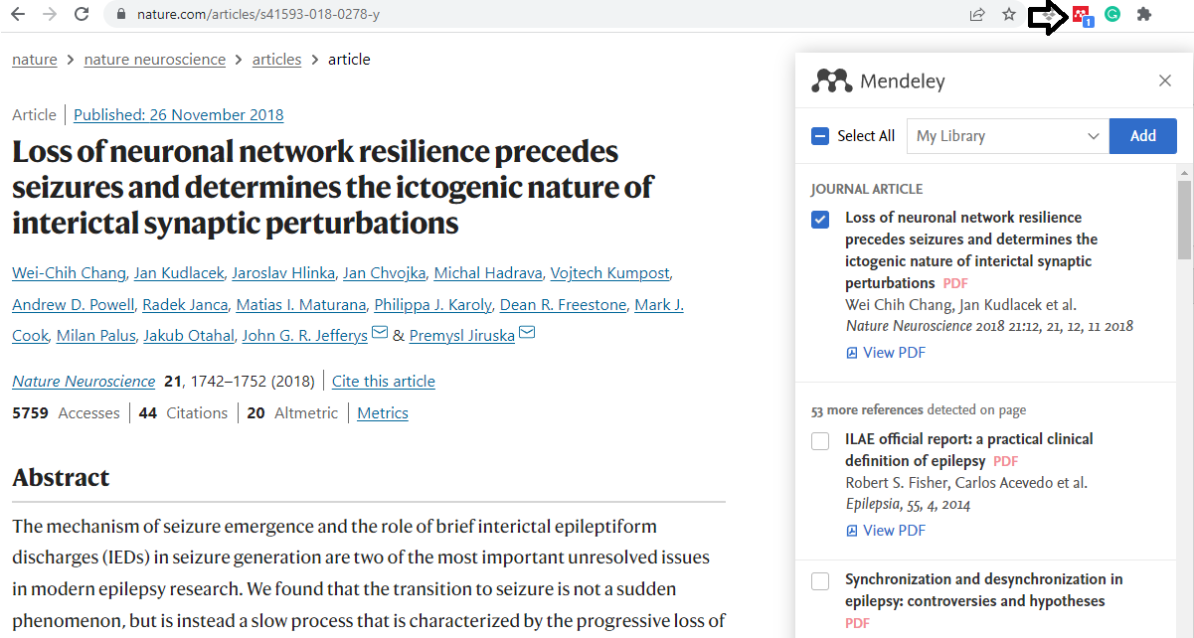
Figure 1: Mendeley Web importer. Arrow marks icon for import. Select the found article and add it to your library.
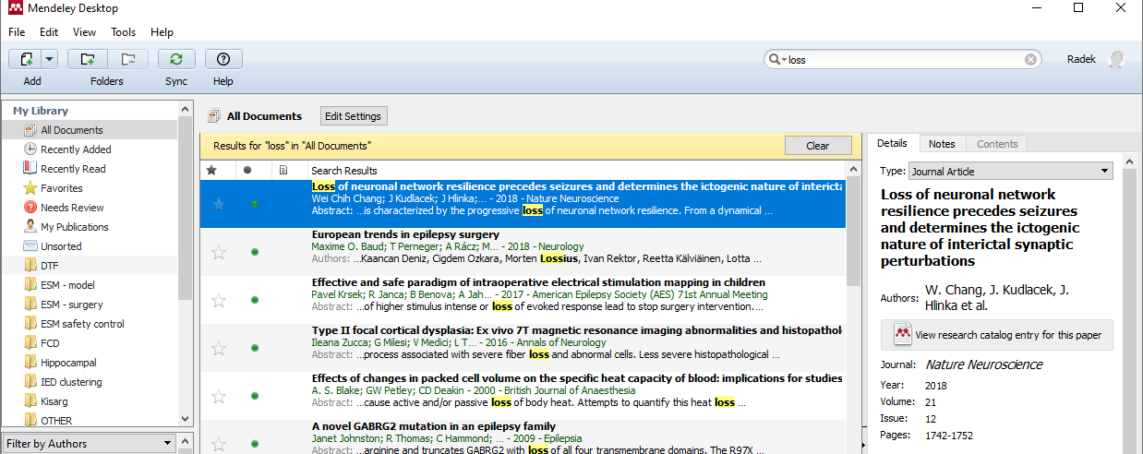
Figure 2: Mendeley Reference Manager. Use Sync button in the main panel. Select newly imported items and check/edit all fields (on the right).
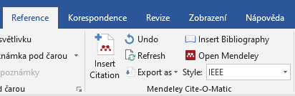
Figure 3: Mendeley MS Office plug-in. Use the Insert Citation button to insert a reference to the text. Select citation style, i.g., IEEE. Generate the reference list by the Insert Bibliography button.

  - Equations
Respect the widely used rules: one-dimension variables, matrix elements are in italic, vectors and matrices are in bold, and physical constants and functions are in normal font. Do not share symbols for different variables, e.g., variable i can not be used for indexing and as a complex unit at the same time, even when redefining them. Mark and refer equation by numbers. The simple equations can be in the text$C=A+B$, complex equations should be in individual lines with numeric references.
For example, A Fourier transform is an integrable mathematical transform that decomposes functions depending on space or time into functions depending on the spatial frequency or temporal frequency, where ω represents the angular speed of frequency f, x(t) is time-series, i is the imaginary unit, and $X\left(ω\right)$ is a complex harmonic spectrum, see equations 1-3.
$ω=2πf$ (1)
$X\left(ω\right)=\int_{-∞}^{∞}{x\left(t\right)e^{-iωt}dt}$ (2)
Fourier transform FT{} should be substituted as
$X=FT\left\{x\right\}$. (3)
Use Equation editor in MS Word and rulers for alignment.

  - Figures
Place the figures between paragraphs or on the top of the page after the first meaning. The resolution should be at least 300 dpi. The figures can be composed of subpanels marked by the big letters, see Figure 4A, B. Examples of other figure referencing are Figure 2A; 3A-C; 4 A, C-D. Use cross hyperlinks.
Legend’s font is 10 pt, smaller than normal text (11 pt). Legend of subpanels precedes high letter in brackets. The figure with legend must be comprehensible separately. Each figure must be mentioned in the text.
Insert figures to “transparent table” in MS Word.

A | B
Figure 4: Logo of CTU in Prague. (A) Blue version for color print, (B) black and white version. Note.: red frames show only subpanels organization

  - Tables
Table referencing is similar to figures, see Table 1. Table legend is above table, abbreviations are below.
Table 1: List of probands
Subject | Age (years) | Education | IQ
1 | 20 | HS | 105
2 | 30 | U | 110
Abbreviations: IQ – intelligent quotient; HS – high school; U – university.
- Headings (level 1) (20 pt)
Use maximal three levels of subsections. The higher heading (X.) represents the main sections, e.g, introductions, material and methods, results, discussion, and conclusion. The same style without numbers is for the reference list and supplementary materials. These sections start on new pages.

  - Subsection (level 2) (16 pt)
The second level (X.X) covers themes. For example, chapter 2. Data and methods will contain subsections: 2.1 Data selection, 2.2 Analytic methods, 2.3 Statistic, etc.

    - Sub-subsection (level 3) (14 pt)
If the themes require the division into sections, use the maximal third level (X.X.X). For another segmentation use a bulleted list:
- Detail 1: text.
- Detail 2: other text.
- Detail 3: or text
Comments and notes should be inserted as footnotes.
References
[1] K. P. Wright, J. T. Hull, and C. A. Czeisler, “Relationship between alertness, performance, and body temperature in humans,” Am. J. Physiol. - Regul. Integr. Comp. Physiol., vol. 283, no. 6 52-6, pp. 1370–1377, Dec. 2002, doi: 10.1152/ajpregu.00205.2002.
[2] W. C. Chang et al., “Loss of neuronal network resilience precedes seizures and determines the ictogenic nature of interictal synaptic perturbations,” Nat. Neurosci., vol. 21, no. 12, pp. 1742–1752, Dec. 2018, doi: 10.1038/s41593-018-0278-y.
[3] R. Janca et al., “Detection of Interictal Epileptiform Discharges Using Signal Envelope Distribution Modelling: Application to Epileptic and Non-Epileptic Intracranial Recordings,” Brain Topogr., vol. 28, no. 1, pp. 172–183, Jan. 2014, doi: 10.1007/s10548-014-0379-1.

Supplementary
Here is a place for the redundant and preliminary results or materials, that support your work with less importance. Their placement in the main text would have caused the thesis hard to read. However, you can reference supplementary materials in the text as Supp. Fig. 1A, Supp. Table 1, Supp. chapter 1, etc.

Footnotes are marked by an upper index in the text.

